WEEK 3 – STATISTICAL ANALYSIS & HYPOTHESIS TESTING
Customer Churn Analysis and Prediction Using Python
Submitted By
ANJALI UMESH

Introduction
This report presents statistical analysis and hypothesis testing using the IBM Telco Customer Churn dataset. The objectives are to test whether customer tenure differs between customers who stayed and those who churned, and whether contract type is associated with churn. Python libraries including pandas, SciPy, Matplotlib and Seaborn were used.

Dataset and Preparation
The analysis uses the cleaned dataset prepared during Week 1. It contains 7,043 customer records and 21 columns. The variables used here are tenure, Contract and Churn. The same cleaned dataset was used for both tests to maintain consistency.

Test 1 – Independent Samples Welch’s t-test
Objective: Determine whether average tenure differs between customers who stayed and customers who churned.
H₀: The mean tenure is equal for the two groups.
H₁: The mean tenure differs between the two groups.
Significance level: α = 0.05.
Welch’s independent samples t-test was used to compare the two group means. It does not require the two groups to have equal variances.
Measure | Result
Average tenure – stayed | 37.57 months
Average tenure – churned | 17.98 months
Difference (stayed − churned) | 19.59 months
t-statistic | 34.8238
p-value | 1.1954945472607151 × 10⁻²³²
95% confidence interval | 18.49 to 20.69 months

The p-value is far below 0.05, so the null hypothesis is rejected. There is a statistically significant difference in average tenure. Customers who stayed had an average tenure about 19.59 months higher than customers who churned. The 95% confidence interval (18.49 to 20.69 months) excludes zero and supports this conclusion.

Test 2 – Chi-square Test of Independence
Objective: Examine whether contract type and customer churn are statistically associated.
H₀: Contract type and churn are independent.
H₁: Contract type and churn are associated.
Significance level: α = 0.05.
A contingency table was created using Contract and Churn, followed by a Chi-square test of independence.
Contract type | Stayed (No) | Churned (Yes)
Month-to-month | 2220 | 1655
One year | 1307 | 166
Two year | 1647 | 48
Measure | Result
Chi-square statistic | 1184.5966
Degrees of freedom | 2
p-value | 5.863038300673391 × 10⁻²⁵⁸
Cramér’s V | 0.4101
Minimum expected frequency | 390.89
The minimum expected frequency is 390.89, greater than 5, so the expected-frequency condition is satisfied.
The p-value is below 0.05, so the null hypothesis is rejected. Contract type and churn are statistically associated. Cramér’s V of 0.4101 indicates a moderate association. The observed churn rates are 42.71% for month-to-month contracts, 11.27% for one-year contracts and 2.83% for two-year contracts. This association does not prove that contract type alone causes churn.

Visualizations

i) Customer Churn Percentage by Contract Type
The grouped bar chart compares the percentage of customers who stayed and churned within each contract category. Month-to-month contracts have the highest churn percentage (42.71%), followed by one-year contracts (11.27%) and two-year contracts (2.83%). This visual supports the Chi-square finding.
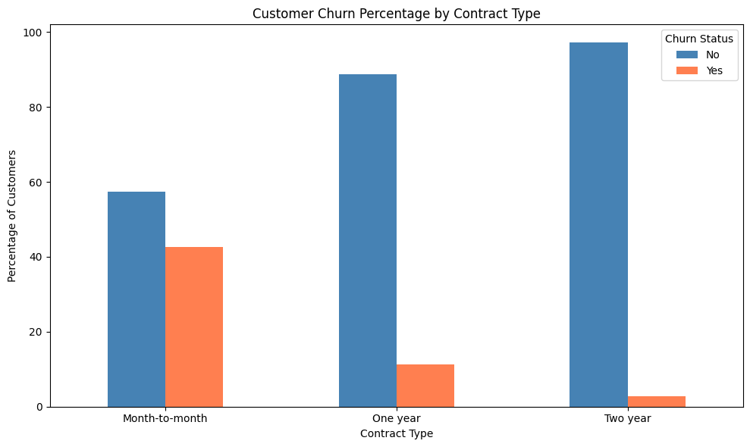

ii) Customer Tenure Distribution by Churn Status
The boxplot compares tenure distributions for customers who stayed and churned. The median tenure is approximately 38 months for customers who stayed and 10 months for customers who churned. Customers who stayed generally have longer tenure. A few churned customers with high tenure appear as outliers. This visual supports the t-test result.
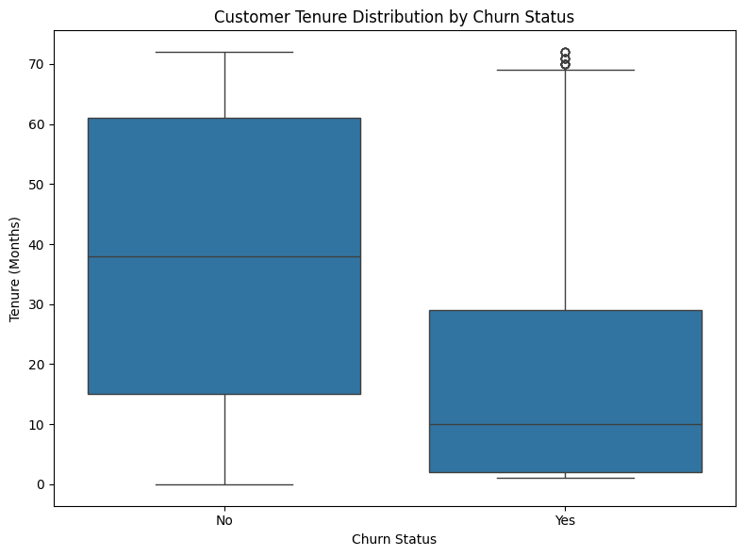

Key Findings
- Customers who stayed had a higher average tenure (37.57 months) than customers who churned (17.98 months).
- The tenure difference was statistically significant; the 95% confidence interval was 18.49 to 20.69 months.
- Contract type was significantly associated with customer churn.
- Month-to-month contracts had a substantially higher churn rate than one-year and two-year contracts.
- Cramér’s V (0.4101) indicates a moderate association.
- The Chi-square expected-frequency condition was satisfied (minimum expected count 390.89).

Conclusion and Practical Implications
The analysis indicates that tenure differs significantly between customers who stayed and those who churned, and that contract type is associated with churn. The company could investigate additional retention support for month-to-month customers and identify why newer customers leave. It could also evaluate suitable longer-term plans and customer engagement initiatives. These recommendations are based on associations in the dataset; the analysis does not establish causation.

